**Dahlia Tuber List 2023**

Ali Oop $9.00 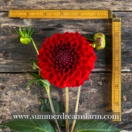 out of stock

American Dawn $14.00 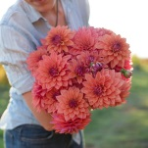 out of stock

Apple Blossom $16.00 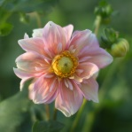

Black Satin $13.00 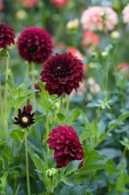

Ben Hudson $18.00 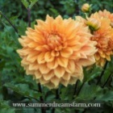 out of stock

Blizzard $11.00 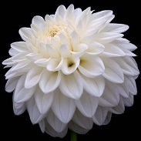

Blyton Softer Gleam $11.00 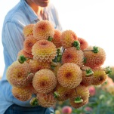

Big Brother $13.00 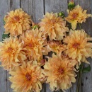

Bracken Sarah $14.00 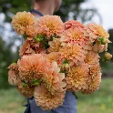

out of stock

Break Out $15.00 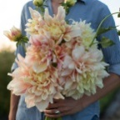 out of stock

Babylon Red $12.00 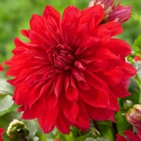 out of stock

B-Man $9.00 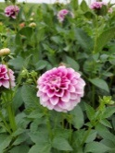

Cafe’ $13.00 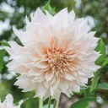 out of stock

Crichton Honey $11.00 

Connecticut Coral $10.00 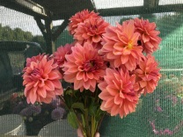

Cornel $10.00 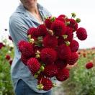

Cornel Bronze $10.00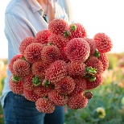 out of stock

Chloe Janae $11.00 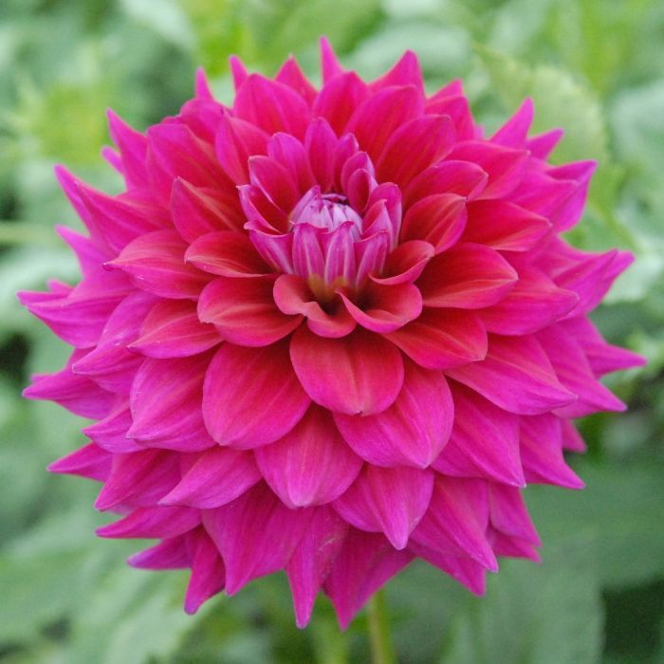

Camano Zoe: $13  out of stock

Camano Buz $10.00 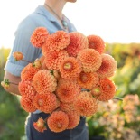

Castle Drive $20 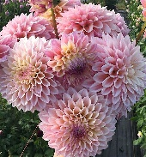 out of stock

David Howard Semi Double $11.00  out of stock

Dorothy $10.00 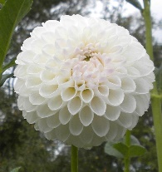

out of stock

Doris Duke $12.00 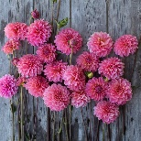 out of stock

Diva $12.00 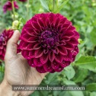

out of stock

Elsie Huston $10.00 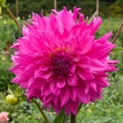

Emory Paul $13.00 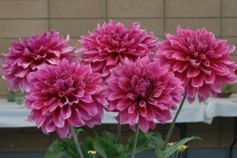 out of stock

Out of stock

Ferncliff Ebony $12.00 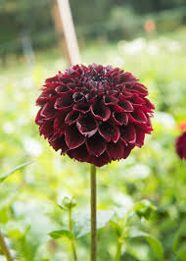

Ferncliff Copper $13.00 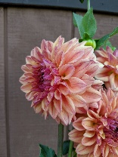

Henriette $13.00 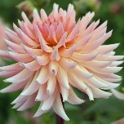out of stock

Hy Suntan $10.00 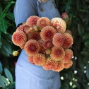

Hillcrest Kismet $15.00 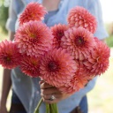 out of stock

Hamilton Lillian $13.00 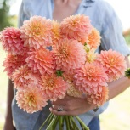 out of stock

Harry Meggos $13.00

Icetea $9.00 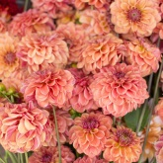

Innocence $12.00 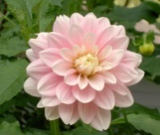 out of stock

Intrique $12.00 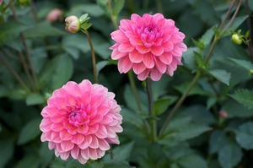out of stock

Ivanetti $10.00 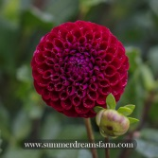

Jomanda $13.00 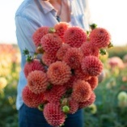 out of stock

Karma Chocolate$14.00 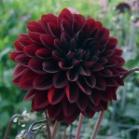

Kenora Lisa $14.00 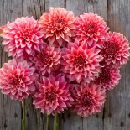 out of stock

Linda’s Baby $12.00 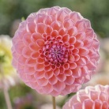

Labyrinth $15.00 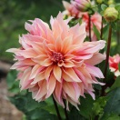

Lovely Lana $10.00 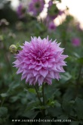

Lupin Chris $9.00 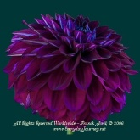 out of stock

out of stock

Lilac Time: $12.00 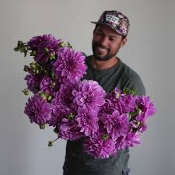 out of stock

Maarn $11.00 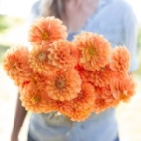

Maltby Pearl $10.00 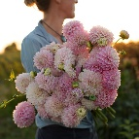

Mambo $11.00 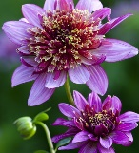

Marty Gras $9.00 

Mystique $12.00 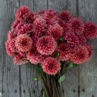 out of stock

Miss Amara $15.00 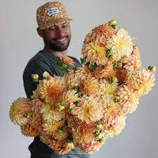

Nathalie G $11.00 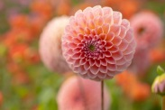 out of stock

Noordyks glorie: $10.00 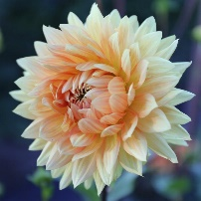

Night Silence $14.00 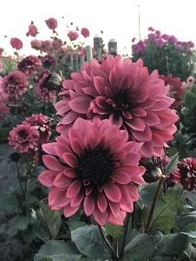

Otto’s Thrill $14.00 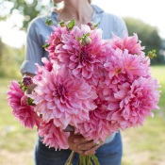 Out of Stock

Orange Globe $22.00 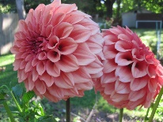 Out of Stock

Peaches N-Cream $20.00 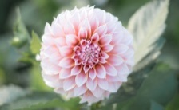 out of Stock

Purple/ Burgundy $11.00 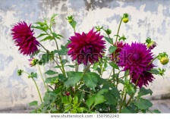

Pumpkin Spice $11.00 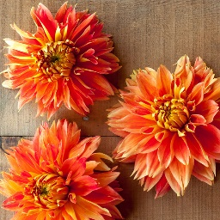

Rip City $11.00 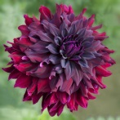

Robann Royal $9.00 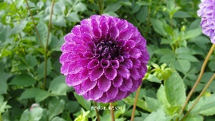

Rock Run Ashely $15.00 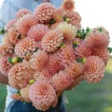 out of stock

Roque Starburst $15.00 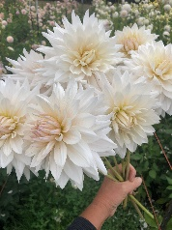

Rose Toscano: $12.00  out of stock

Sandra $10.00 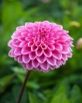 out of stock

Sandia Brocade $12.00  out of stock

Senior’s Hope $13.00 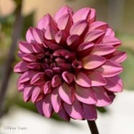out of stock

Sherwood’s Peach $13.00 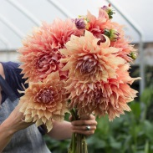

Sierra Glow $15.00 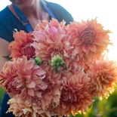

Sparticus $13.00  out of stock

Sugartown Sunrise $13.00 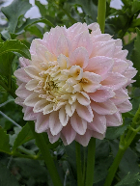 out of stock

Scaur Swinton $15.00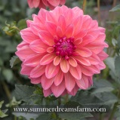 out of stock

out of stock

Salmon Runner: $12.00 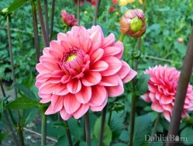

Terracotta $10.00 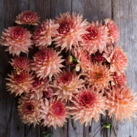

Totally Tangerine $15.00 out of stock

Tempest $11.00 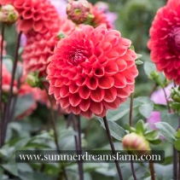 out of stock

Thomas Edison $12.00 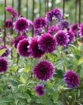 out of stock

White Alva $11.00 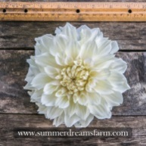

out of stock

Yuu Kyu $12.00 